AUTHOR BIO: PETE RISINGSUN
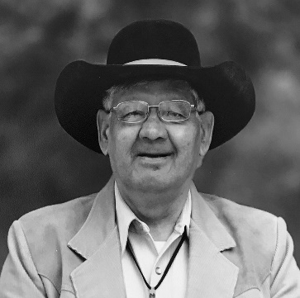
Pete Risingsun is an enrolled member of the Northern Cheyenne Tribe. He is recognized as a Ceremonial Man who is well-versed in his tribe's ceremonies and traditions of the Creator's circle of life. His experience includes serving as a spirit helper to medicine men in ceremonial sweat lodges, where traditional procedures are meticulously followed. Sweat lodge keepers earn their right to function in that role. After completing his vow to fast four times at the Sacred Mountain, he earns four paints, each of which has important ceremonial significance.
Pete Risingsun
Pete is a proud fifth generation descendant of Iron Shirt, his great-great-grandfather, who was a lodge keeper and powerful medicine man who lived to be 98 years old. At 95, he still rode his white horse to the Busby, Montana fair. A ceremonial medicine man warrior, his buckskin Cheyenne war shirt had powerful medicine that made him fearless. The buckskin would turn to iron during battle and the soldiers' bullets would fall to the ground. Iron Shirt is shown below on the left. Next to him is Philip Risingsun, then Pete Risingsun (Author Pete's grandfather), and Harry Risingsun (Author Pete's uncle.)
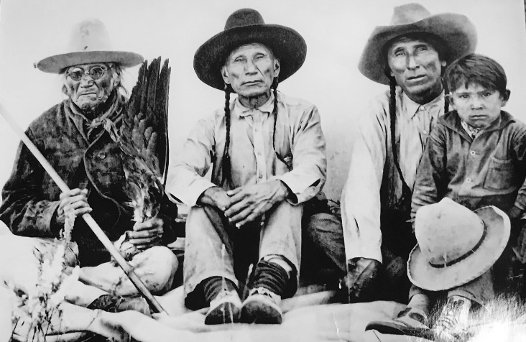
Picture taken c. 1927 by Dr. Thomas B. Marquis. Copyright Risingsun family, used with permission.
Pete was born in 1950, the eighth child of ten, and raised on a small ranch east of Busby, Montana, where he became a horseman and hunter at a very young age. When he was twelve, he shot his first deer and also caught a young bald eagle. He and his uncle, David Seminole, raised it in a large cage for three years. They took four tail feathers for Pete's traditional dancing bustle and then set the eagle free. This uncle taught him traditional dancing as well as how to ride a horse.

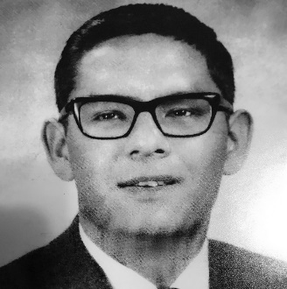
His high school graduation picture is shown on the left. After graduating high school in 1968 he attended Montana State University for four years, then was offered a position with Exxon as an employee relations director overseas. He turned it down, instead completing a three-year apprenticeship in plant operations and working in that capacity for one additional year in Billings, Montana. Working in a refinery a hundred miles from home combined with the discomforts of shift-work made him crave the smell of fresh air as well as getting outside astride a good horse.
Years before, his uncle, Ted Risingsun, had told him, "You younger Cheyennes with education need to come home and help your people. Do not forget where you came from." Thus, when he was offered a job as adult education director for the Northern Cheyenne Tribe back home in Lame Deer, he accepted, grateful to see Billings and the refinery fade away in the rear-view mirror.
Upon returning to the reservation, Pete also bred championship American Quarter Horse Association (AQHA) horses, guaranteeing he'd have a good ride available whenever he wanted. He also raised black angus cattle.
His Uncle Ted further encouraged him to follow in his footsteps and become a Tribal Council member. He heeded his advice and served on the Council for six years. In addition, Pete's leadership includes being the first Northern Cheyenne elected as a Rosebud County Commissioner, a position he held from January 1, 2007 to December 31, 2012.
He's the proud father of one daughter, Echo Raine, who blessed him with two very special grandchildren, Sierra Star and Skyler Seven. He's teaching his grandson about the Cheyenne way of life, which has so far included a sweat lodge and cloth ceremony. Upon graduating from high school, Skyler plans to attend college to earn a degree in a technological field.
Pete is currently retired and celebrating the completion of the Dead Horse Canyon Trilogy. Regarding his experience with this story, he states, "My hope is for the reader to enjoy these books as much as I have enjoyed being the co-author. I write in the spirit of truth based on my spiritual life experiences as a spirit helper to medicine men in the ceremonial sweat lodge."
High School Senior (1968)

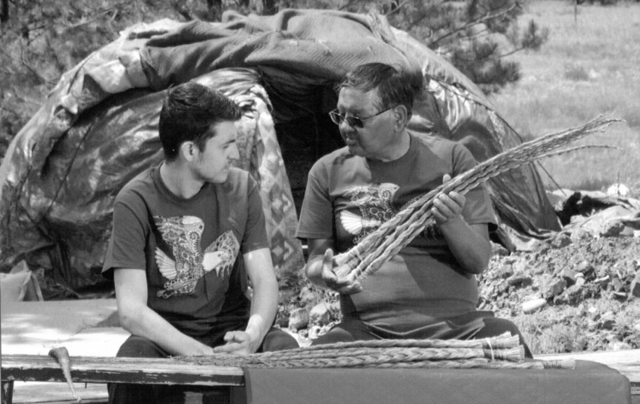
Pete showing his grandson, Skyler, some of his sweet grass braids.

ABRIDGED (350 WORDS)

Pete Risingsun is an enrolled member of the Northern Cheyenne Tribe. He is recognized as a Ceremonial Man who is well-versed in his tribe's ceremonies and traditions of the Creator's circle of life. His experience includes serving as a spirit helper to medicine men in ceremonial sweat lodges, where traditional procedures are meticulously followed.
Born in 1950, he was the eighth child of ten, and raised on a small ranch east of Busby, Montana. He's a proud fifth generation descendant of Iron Shirt, his great-great-grandfather, who was a lodge keeper and powerful medicine man warrior.
After graduating high school in 1968 he attended Montana State University for four years. He was offered a position with Exxon as an employee relations director overseas. He turned it down, instead completing a three-year apprenticeship in plant operations and working in that capacity for one additional year in Billings, Montana. When he was offered a job as adult education director for the Northern Cheyenne Tribe back home in Lame Deer, he accepted, grateful to see Billings and the refinery fade away in the rear-view mirror.
Upon returning to the reservation, Pete bred championship American Quarter Horse Association (AQHA) horses and raised black angus cattle. He served as a Tribal Council member for six years and was the first Northern Cheyenne elected as a Rosebud County Commissioner, a position he held from January 1, 2007 to December 31, 2012.
He's the proud father of one daughter, Echo Raine, who blessed him with two grandchildren, Sierra Star and Skyler Seven. Pete is currently retired and celebrating the completion of the Dead Horse Canyon trilogy.

